Project: One Point Perspective Shooting Shapes
Overview: Today we are working through one point perspective by drawing geometric shapes around the vanishing point and drawing lines back-this creates the illusion of space. Finish off the drawing by coloring in the shapes and shading to increase the illusion (note that as objects recede they are less clear and typically lighter in value).

Supplies:
- Paper
- Pencil
- Eraser
- Something to color with (markers, crayons, colored pencils)

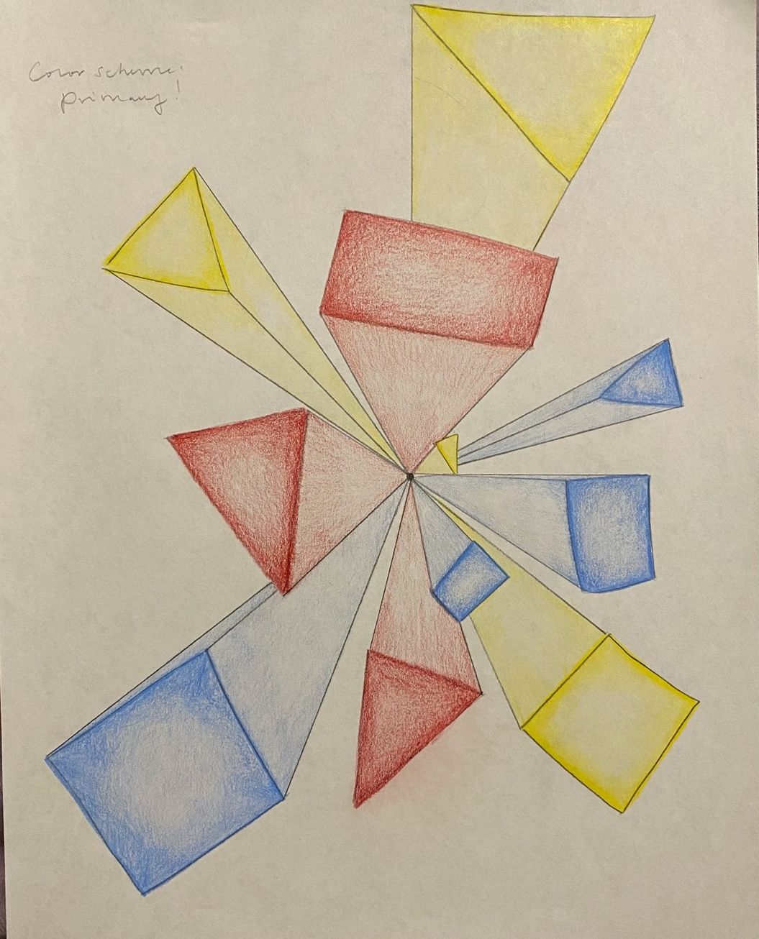

Project: Tint/Shade Ice Cream
Overview: Today we are going to start by drawing an ice cream cone, from there we are talking about color and the difference between a tint and a shade. A tint is a value (color) that is lighter (typically achieved by adding white, for instance pink). A shade is a value (color) that is darker (by adding black of grey, for instance maroon).

Supplies
- Pencil
- Eraser
- Paper
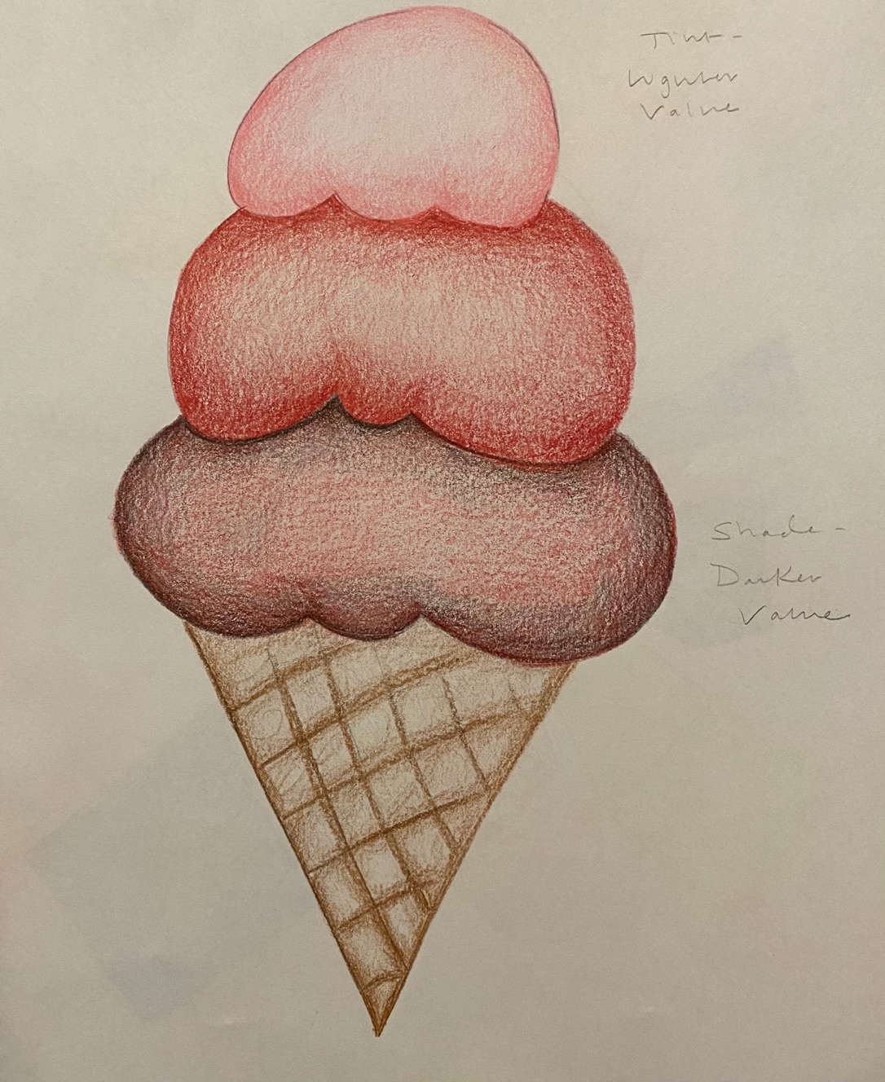
- Something to color with (markers, crayons, colored pencils, etc.)

