Project: Stained Glass
Overview: Today, we are making a drawing that resembles stained glass. We will divide up the negative space and color in the sections. When we are done coloring, we will remove the tape and reveal clean lines in between the colors. I challenged you to use a color scheme to complete. Mine below is a secondary colors scheme (purple, orange and green).

Supplies:
- Paper
- Pencil
- Something to color with (crayons, markers, colored pencils)
- Tape
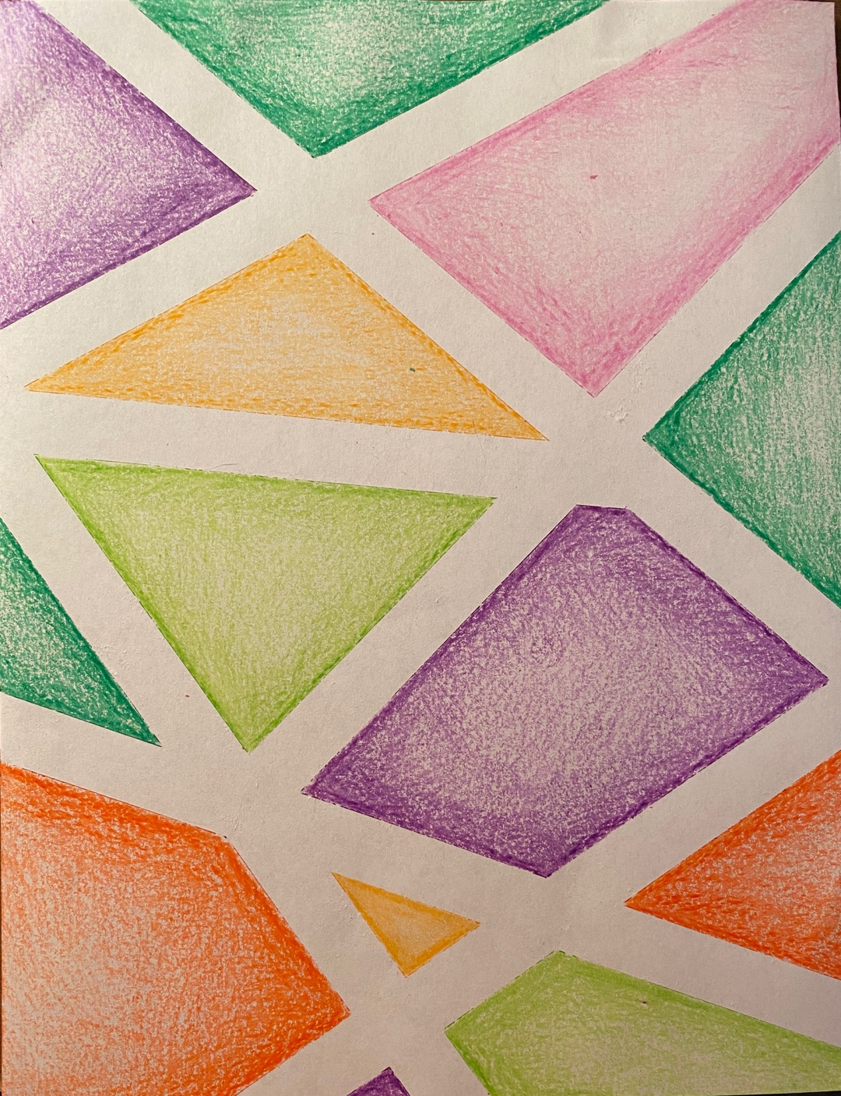

Project: How to draw and eye
Overview: Today, we are going to learn how to draw a 3D eye. Working through some observational drawing and shading techniques. The video includes some tips and tricks for drawing a realistic eye.

Supplies
- Paper
- Pencil
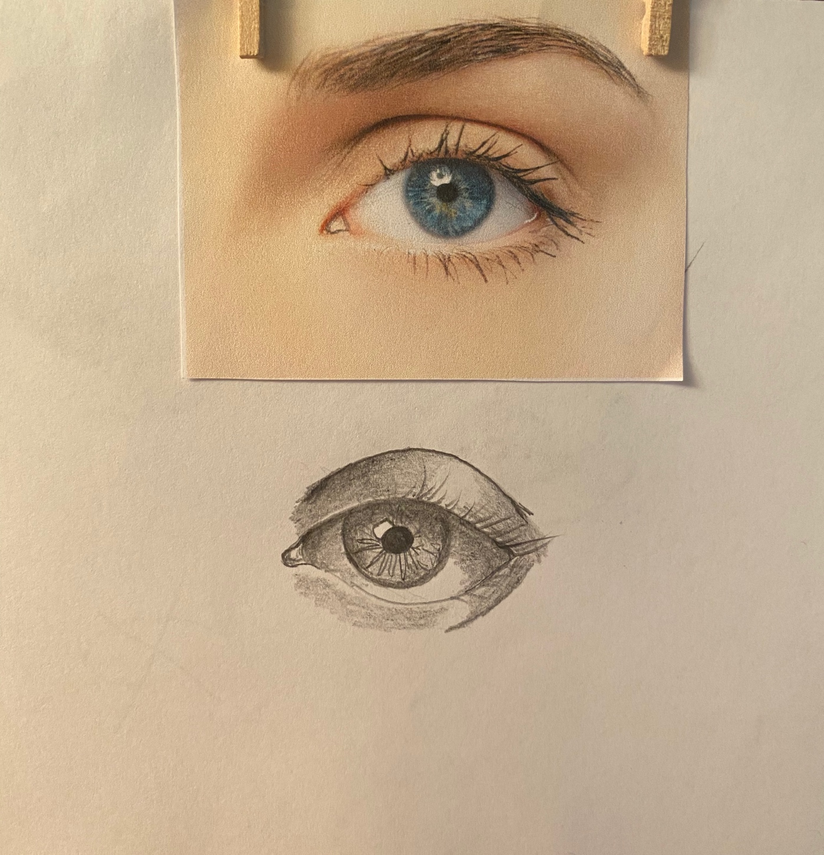
- Eraser

