Project: Aquarium Perspective
Overview: Today, we are going to learn about perspective by creating an aquarium. We will start by creating a vantage point and adding details in the floor and ceiling. We will use our own imaginations and creativity to add fish, divers and other sea creatures.

Supplies:
- Paper
- Pencil
- Ruler (optional)
- Black marker (optional)
- Something to color with! (colored pencils, crayons, markers, etc.)

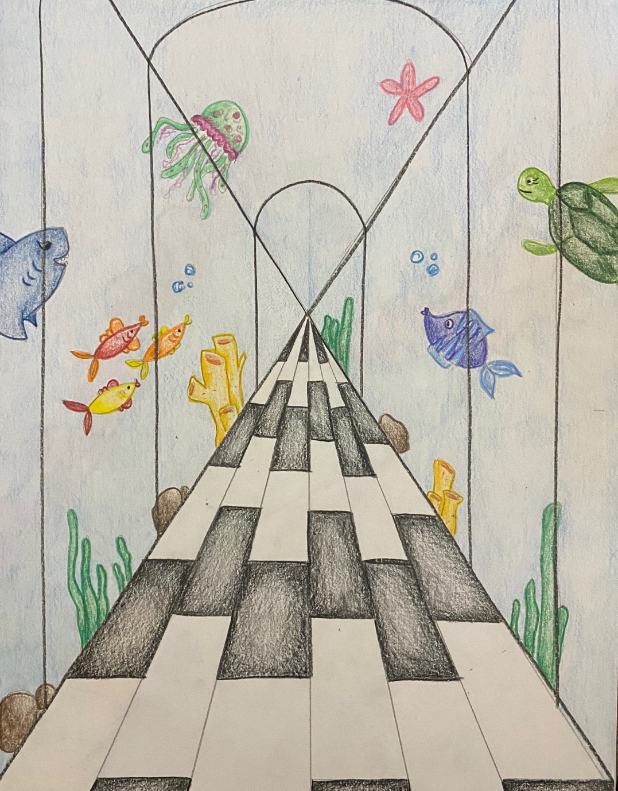

Project: Hand Dragon/Dinosaur
Overview: Today, we are going to learn how to draw a simple dragon/dinosaur using the outline of our hand. We will work on our creativity by adding color and background images that tell a story.

Supplies
- Paper
- Pencil
- Eraser
- Black marker
- Something to color with (colored pencils, crayons, markets, etc.)
