Project: Name Monsters
Overview: Today, we are going to work on name monsters! We will practice our writing skills (either cursive or print) with your names. Then we will use our creativity to create a monster from those lines, adding shape, texture and color to make your monsters come alive.

Supplies:
- Paper
- Pencil
- Sharpie or black school marker
- Something to color with! (colored pencils, crayons, markers)

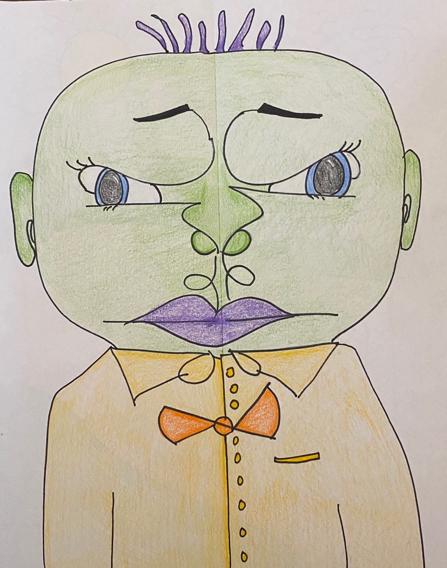

Project: Pattern Landscapes
Overview: Today, we are going to start talking about landscapes and pattern. To begin we will go over foreground, midground and background. We will then use markers to create interest by adding color and pattern to each.

Supplies
- Paper
- Pencil
- Sharpie or black school marker
- Markers or colored pencils
