Project: How to Draw a Reindeer
Overview: Today we are on a step-by-step drawing of a reindeer. We will start with the head and build off ears, antler and the body. Then we will add details like the scarf, eyes and a nose. You decide if this is Rudolph or another of Santa’s Reindeer!

Supplies:
- Paper
- Pencil
- Eraser
- Something to color with (markers, crayons, colored pencils)

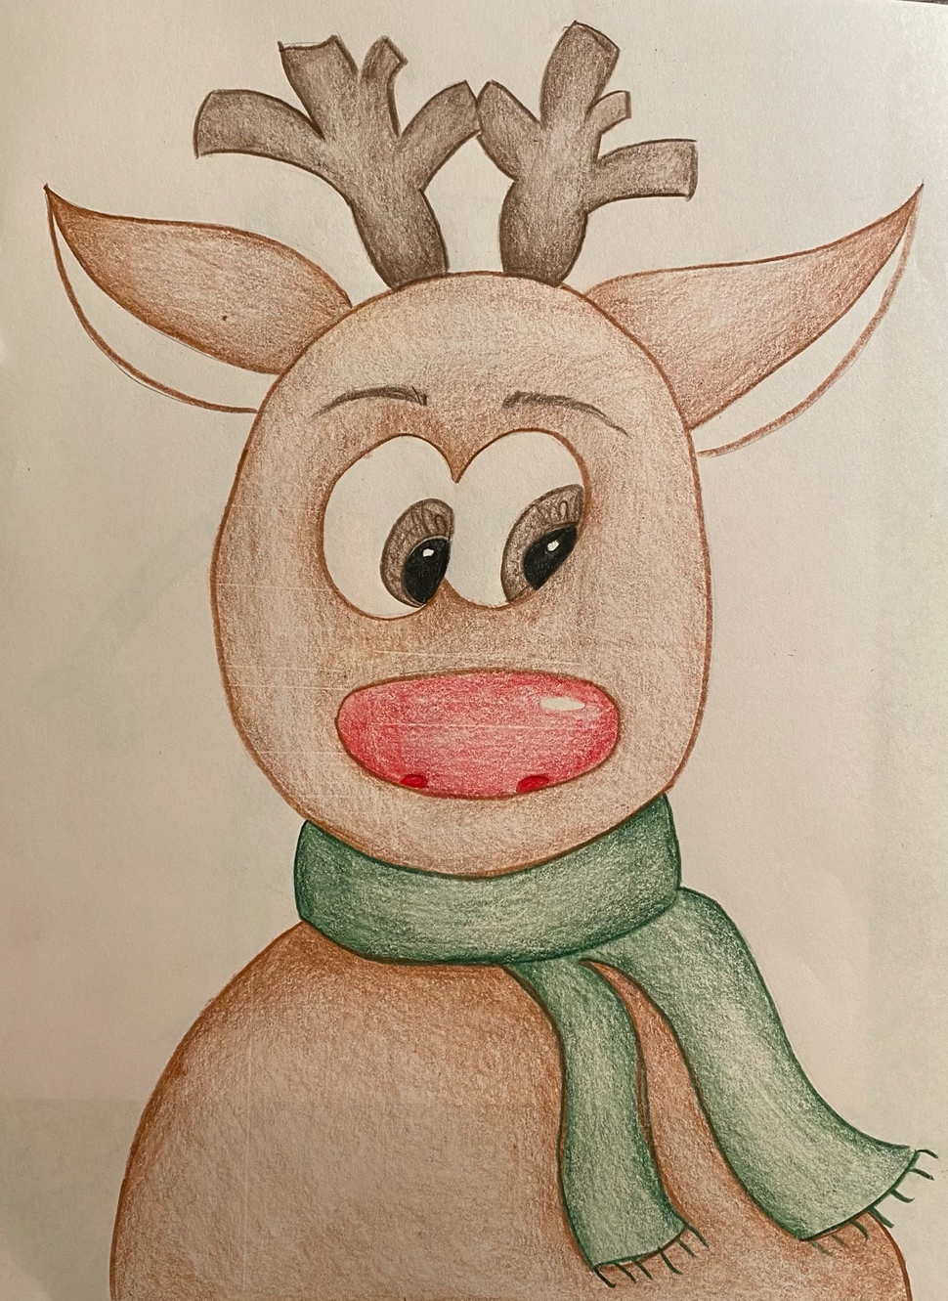

Project: How to Cut a Snowflake
Overview: Today we are going to talk about cutting a unique snowflake from a piece of copy paper. We will begin by making the paper a perfect square and continue on with some folding. Finally cutting out our design and revealing our one-of-a-kind snowflake! Now to hoping some real ones come before Christmas!

Supplies
- Pencil
- Eraser
- Paper
- Scissors
- Glue
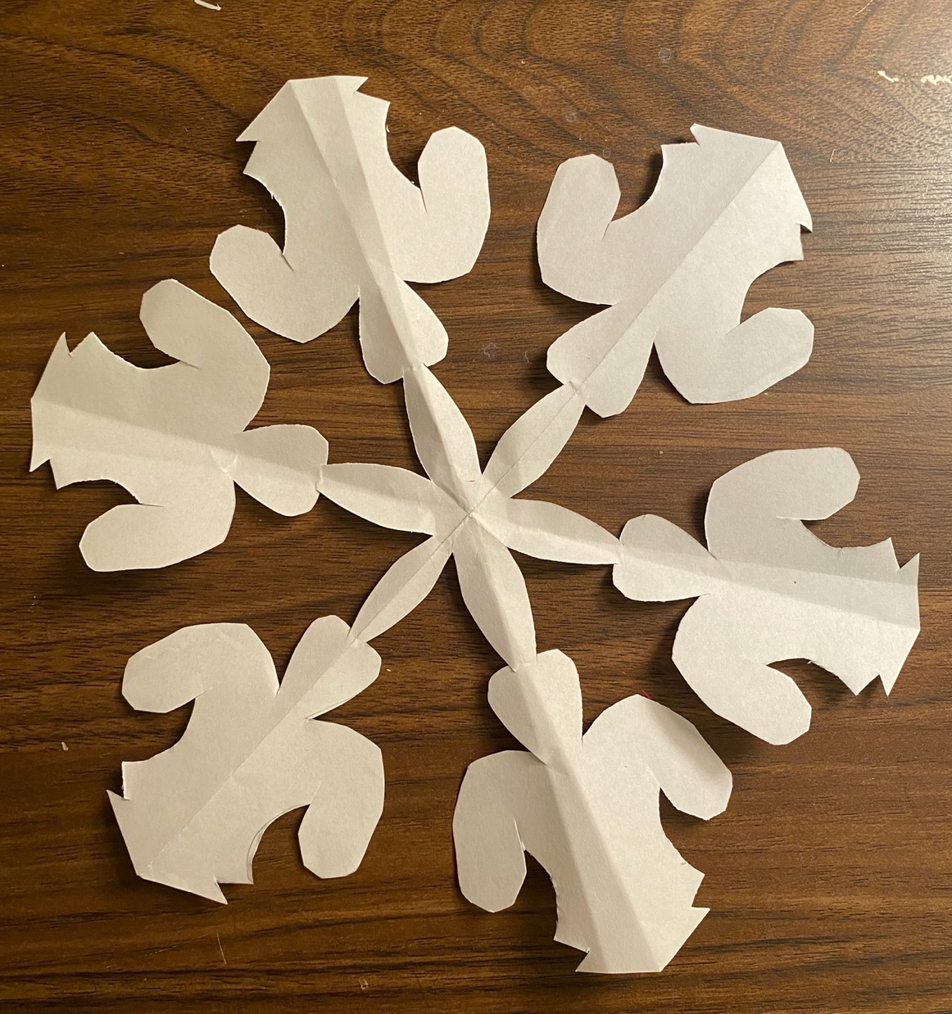

Project: Two-Point Perspective Christmas Presents
Overview: Today we are working through two point perspective and drawing a stack of presents. We will begin with a straight line and make a cube, continuing with that same idea to create a variety of sized packages. Decorate how you choose, adding ribbon and wrapping paper how you please.

Supplies:
- Paper
- Pencil
- Eraser
- Something to color with (markers, crayons, colored pencils)
