Project: Day of the Dead Skeleton
Overview: Today we are going to draw out a day of the dead skeleton. Including the skull and the neck pieces. From there you will decorate your skull how you please. Potentially adding flowers, gems and pattern to make it unique!

Supplies:
- Paper
- Pencil
- Eraser
- Something to color with (markers, crayons, colored pencils)

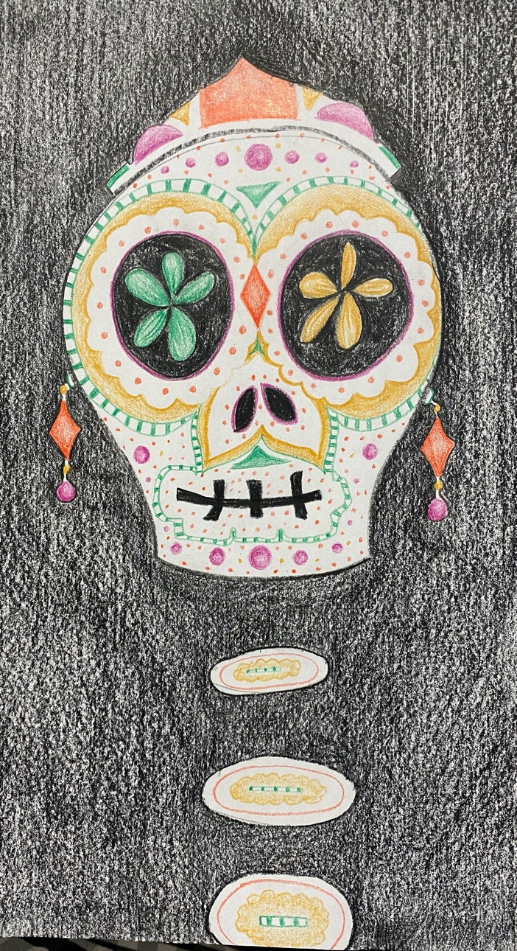

Project: Polka Dot Pumpkin
Overview: Today we are going to draw a pumpkin, shade it with orange and yellow and add polka dots to accent. This will be cut our and placed on a patterned background of your choosing.

Supplies
- 2 Pieces of Paper
- Pencil
- Eraser
- Scissors
- Gluestick
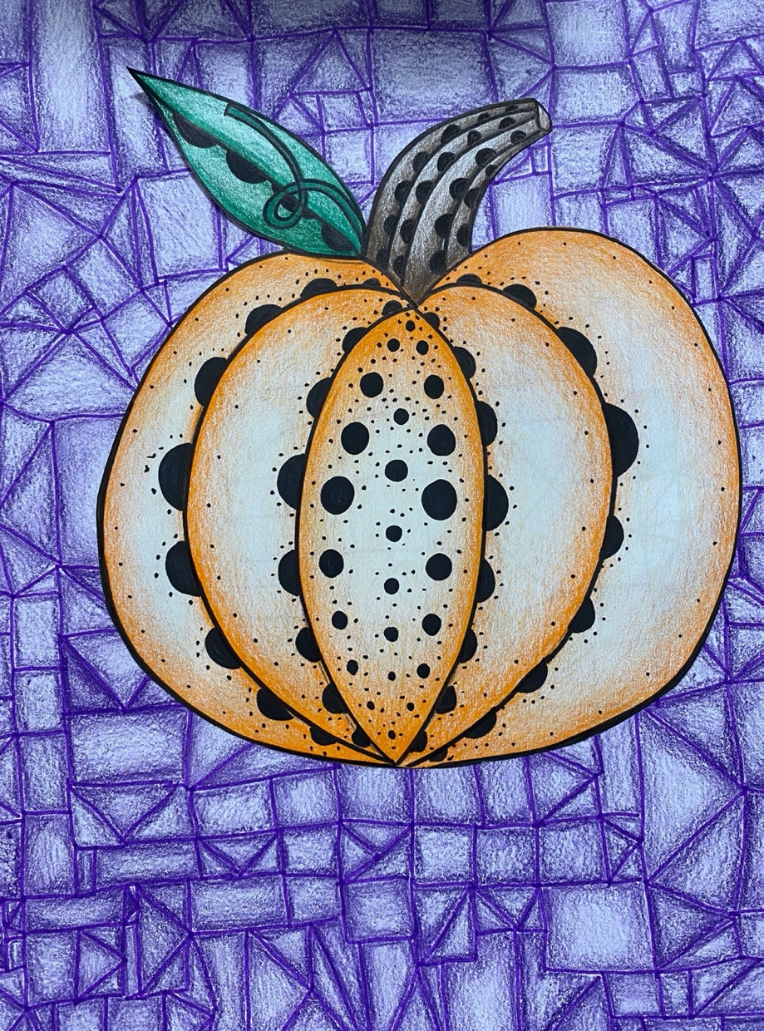
- *Optional something to color with (markers, colored pencils, crayons, etc.)

