Project: Watercolor Floral Wreath
Overview: Today we are learning about watercolor painting. Specifically line work and keeping colors separate. To start very lightly draw a circle of where you want your wreath to be (this helps keep things round). Next we are going to get out paint prepped, do so by dropping a couple drops of water into each color you plan to use. For this project, try to keep your colors relatively close to each other on the color wheel (warm or cool). This will help prevent bleeding and getting gross green/brown shades.

Supplies:
- Paper (watercolor or copy)
- Pencil
- Eraser
- Watercolor paint
- Paintbrush
- Water cup
- Paper towel

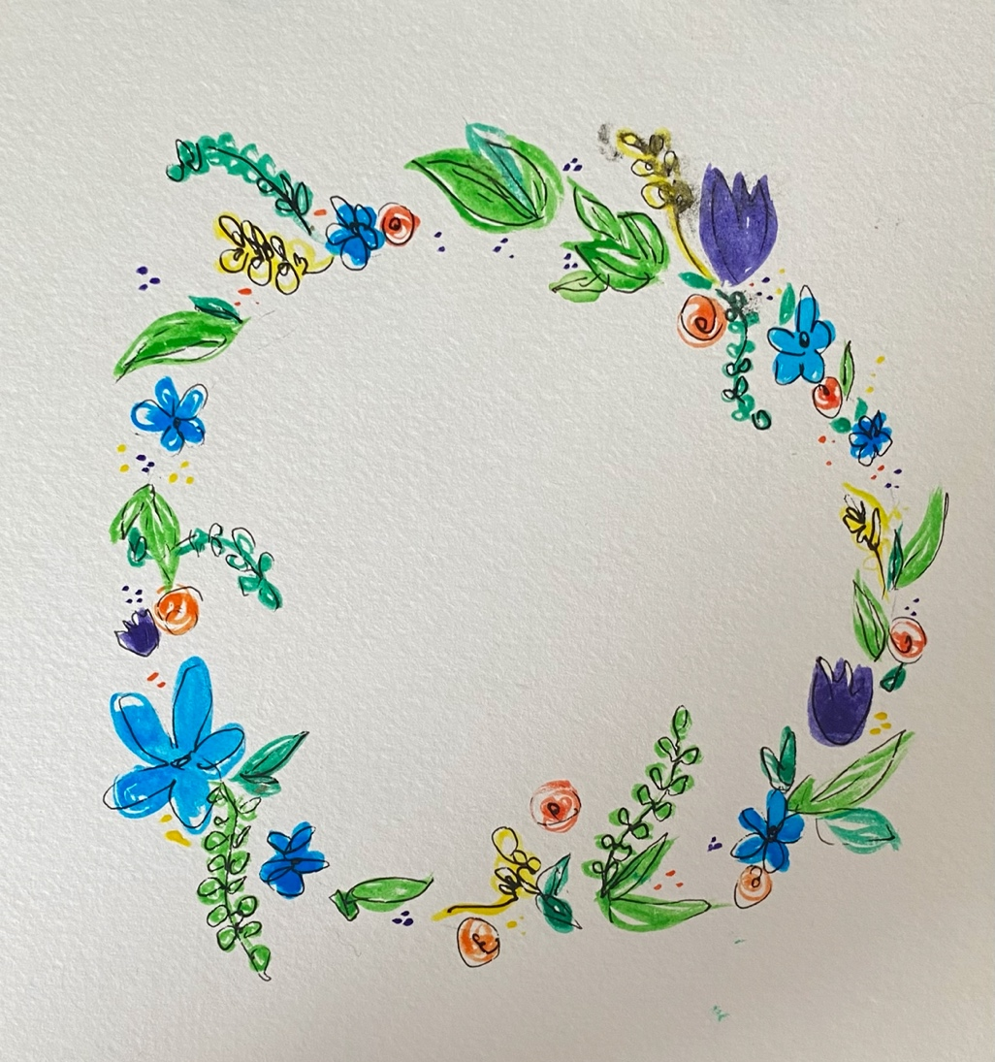

Project: Blow Painting: Germs
Overview: Today we are going to talk about watercolor painting! Just the basics. First we are going to talk about getting your paint prepped. To do so, drop a couple drops of water in each color you are going to use, try to limit this to 2-3 colors. Afterwards, take one color at a time and create blobs of paint, then use your straw to blow out the edges! Repeat with other colors as necessary. Once you are finished, draw and glue some eyes to bring your ‘germ’s to life!

Supplies
- Paper (watercolor or copy)
- Pencil
- Eraser
- Watercolor paint
- Paintbrush
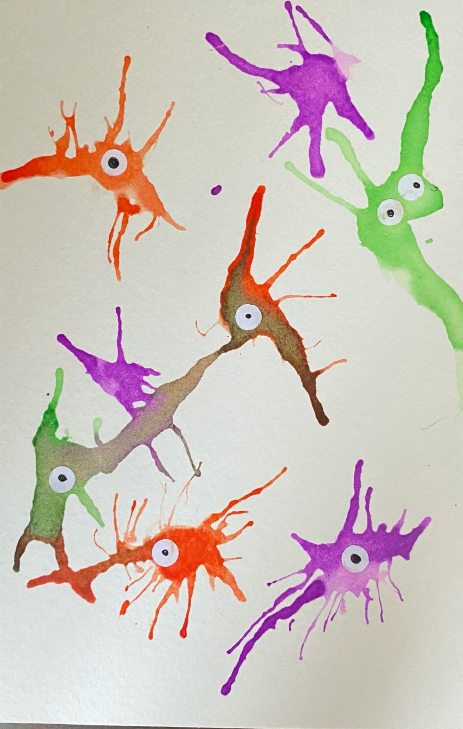
- Water cup
- Paper towel
- Straw

