Project: Scribble Art
Overview: Today we are going to start by drawing a scribble on our paper, make sure that your lines create nice spaces in between. We will then talk about filing in those empty areas with color and pattern. I used a monochromatic color scheme (tints and shades of red) and used stripes and polka dots as my patterns.

Supplies:
- Paper
- Pencil
- Eraser
- Something to color with (markers, crayons, colored pencils, etc.)

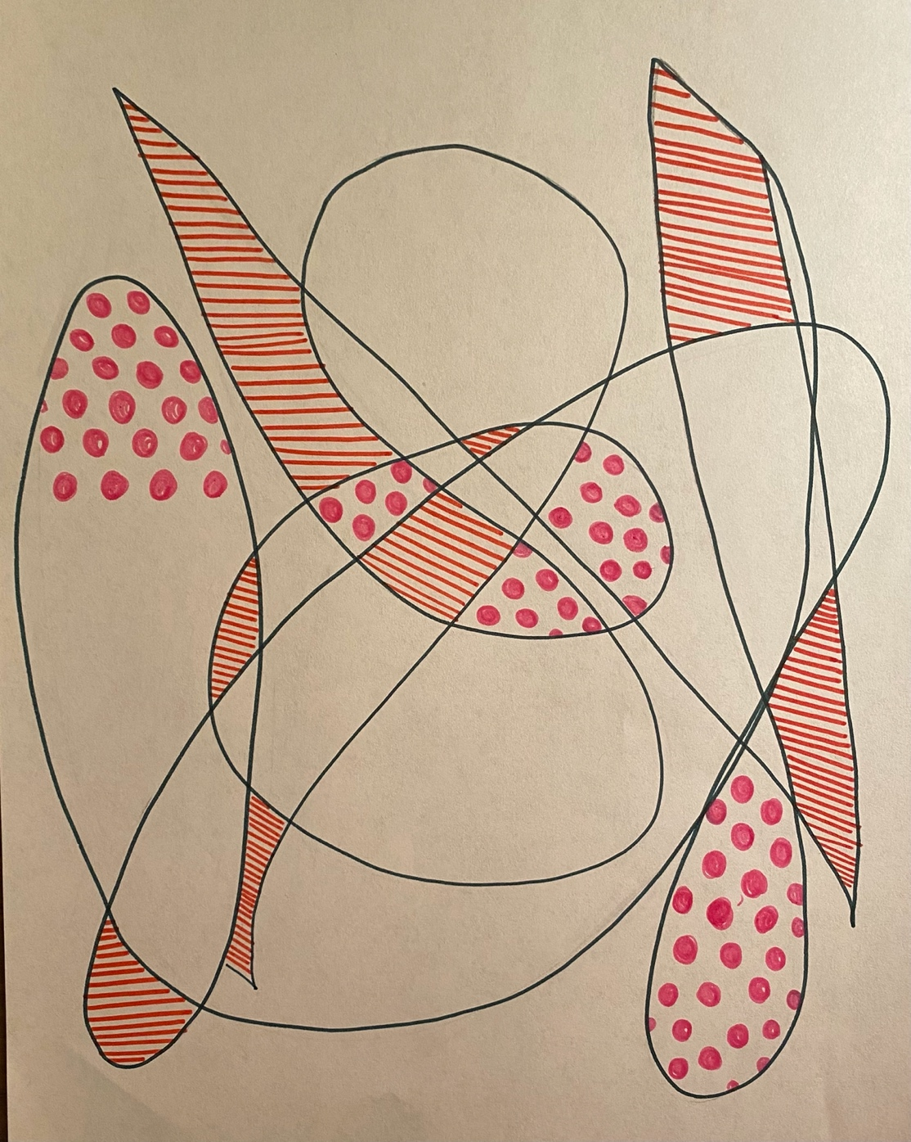

Project: How to Draw a Snowman
Overview: Today we are going to draw a snowman! With the weather getting pretty chilly outside, I thought it would be fun to learn step-by-step how to draw a snowman! Start with the round head and follow along as I go over everything from a stocking cap to a carrot nose! Once we’re finished, color your snowman however you wish.90õ

Supplies
- Paper
- Pencil
- Eraser
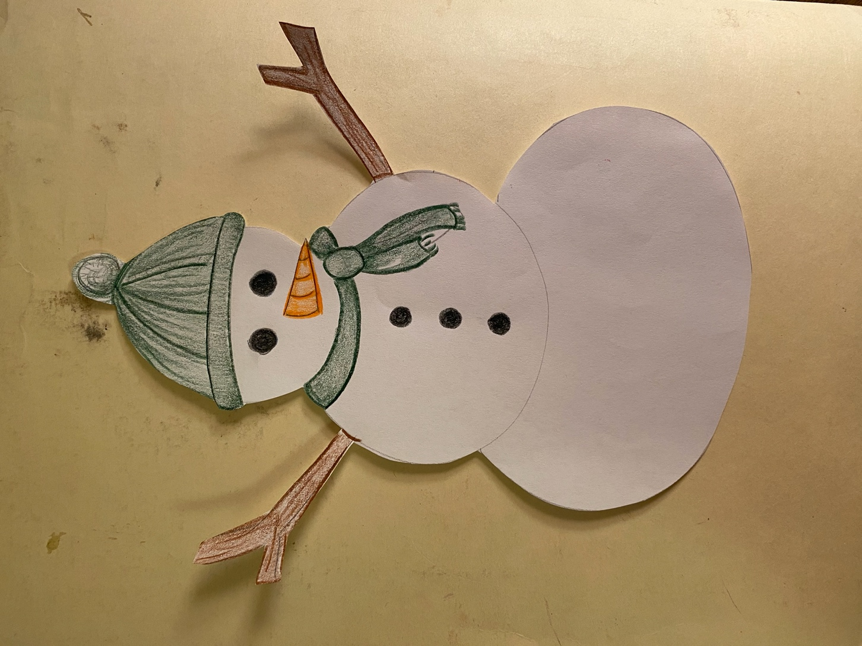
- Something to color with (markers, crayons, colored pencils, etc.)

