Project: How to Draw a Veteran’s Day Poppy
Overview: For Veterans Day this week I am giving step by step instructions on how to draw an poppy. From there, we are going to color and design poppy with red petals and a black or yellow inside. Once you are finished, cut it out and glue onto black paper.

Supplies:
- Paper
- Pencil
- Eraser
- Something to color with (markers, crayons, colored pencils)
- Black paper
- Scissors
- Glue

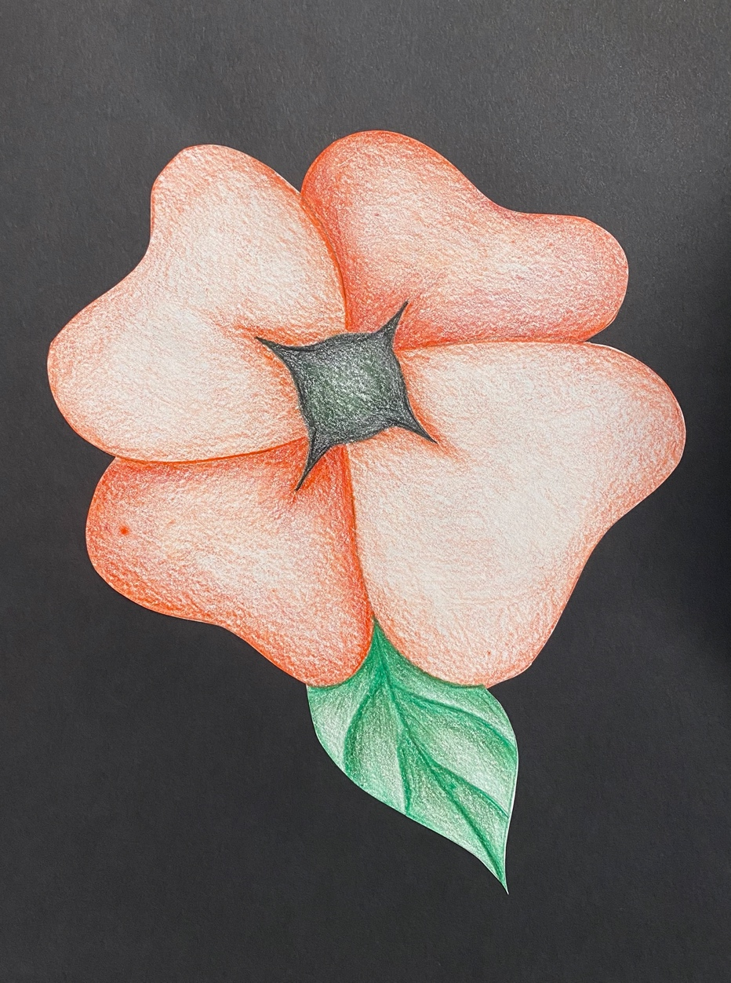

Project: Creative Hands
Overview: Today is more of a prompt or a challenge to draw a creative hand. Instead of fingers, design you hand to have other objects. For instance, mine I include a phone charger instead of a pinky. You can keep one finger so choose carefully! Shade/color your hand once you’re done.

Supplies
- Pencil
- Eraser
- Paper
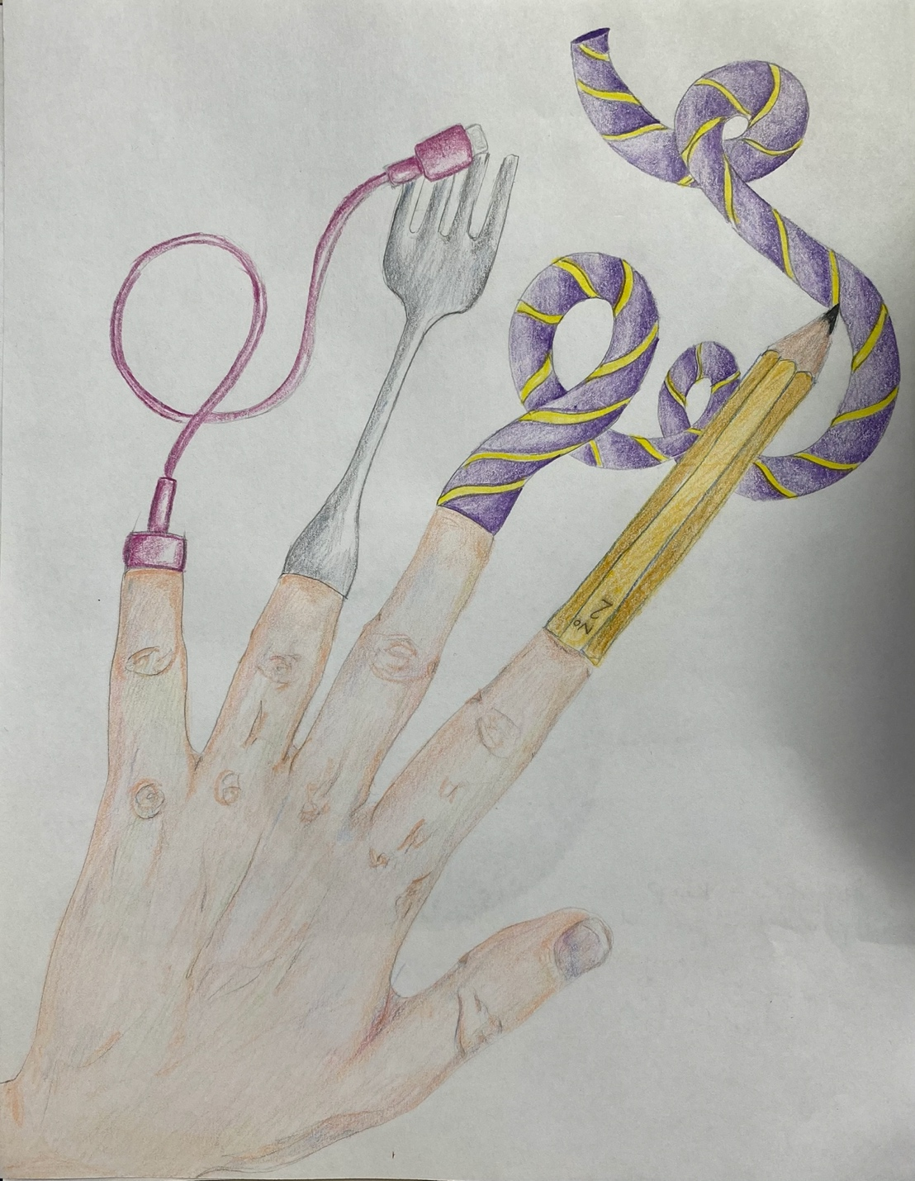
- Something to color with (colored pencils, crayons, markers, etc.)

